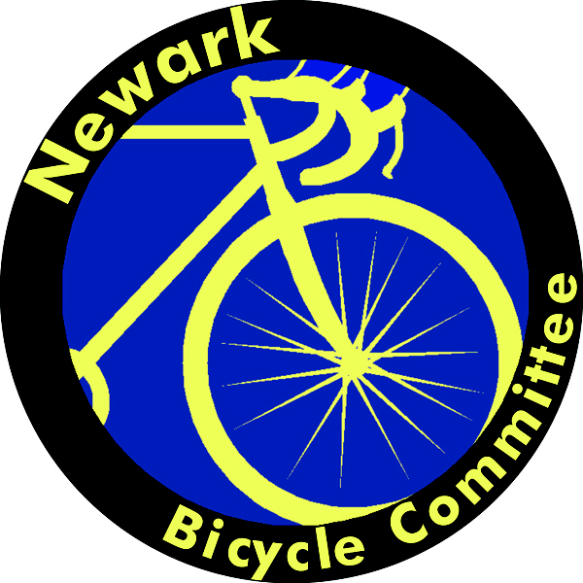

Newark Bicycle Committee

www.wilmapco.org/bikenewark

FOR IMMEDIATE RELEASE

Newark, DE April 15, 2013

Tuesday, May 14th is Bike to Work Day in Newark.

In partnership with the City of Newark and the University of Delaware, the Newark Bicycle Committee is organizing this year’s Bike to Work Day event in Newark. The event will be held from 7:30–10 a.m. on the Trabant University Center patio at the corner of Delaware and South College Avenues. Speakers will be University President Patrick Harker, Delaware Secretary of Transportation Shailen Bhatt, Sen. David Sokola, Rep. Paul Baumbach, and Newark Mayor Vance Funk III.

This event is intended to highlight National Bike Week (May 13-17) in the Newark community—currently a League of American Bicyclists–designated bronze-level “Bicycle Friendly Community.”

Local businesses will be sponsoring the event by providing light breakfast food for participants to enjoy before completing their commutes to work. The Delaware Department of Transportation (DelDOT) will be providing a limited number of free event T-shirts while they last.

In addition to DelDOT, the Newark Bike Project and WILMAPCO will also be present to help the Newark Bicycle Committee ensure the success of this event as a means of drawing attention to the importance of bicycling as transportation, recreation, and a source of economic development in this community.
The Newark Bicycle Committee is a partnership of interested cyclists and agencies working to improve bicycling in Newark, Delaware.

Mark Deshon

Coordinator, 2013 Bike to Work Day in Newark
302-738-9524, deshon@udel.edu

